

**Configure a basic FortiGate firewall from factory settings and set up initial security policies.**

R2_DEPI2_ONL2_ISS6_S1_Fortinet Cyber Security Engineer

Spring semester 2024-2025

**Supervisor**

**Eng.Nehal Ahmed**

**Created by:**

**1-Nada Ehab Ghorab**

**2-Ziad Waled Ibrahim**

**3-Ahmed Mohamed Sobhy**

**4-Menna Mohamed Sayed**

**5-abdelrahman ebrahem**

**6-mazen amr mohamed**

**1-At the first we change the factory password of fortigate and put new complex password**

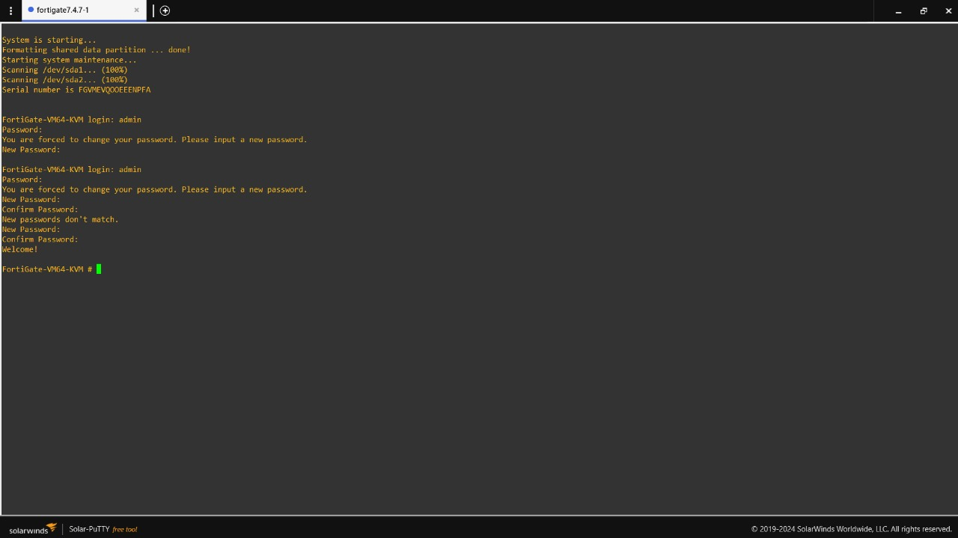

**2-Second we configure ports of fortigate**

**Firstly Lan port:-**

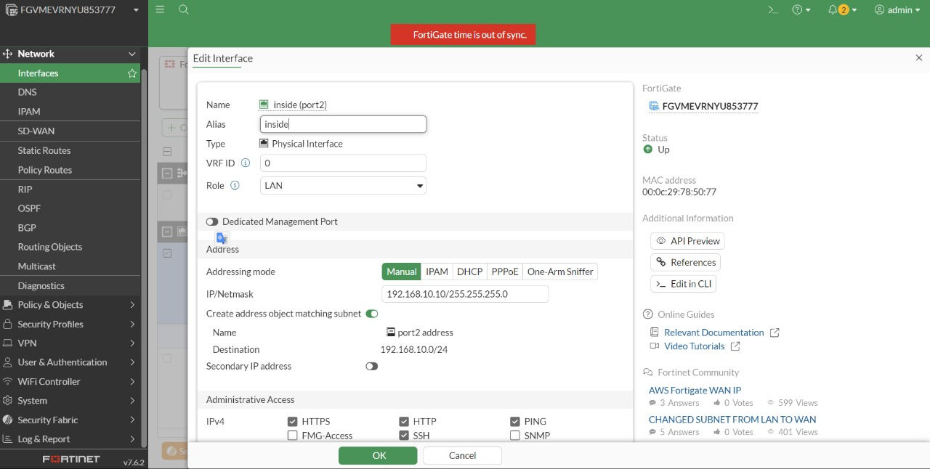

**And Secondly Wan port:-**

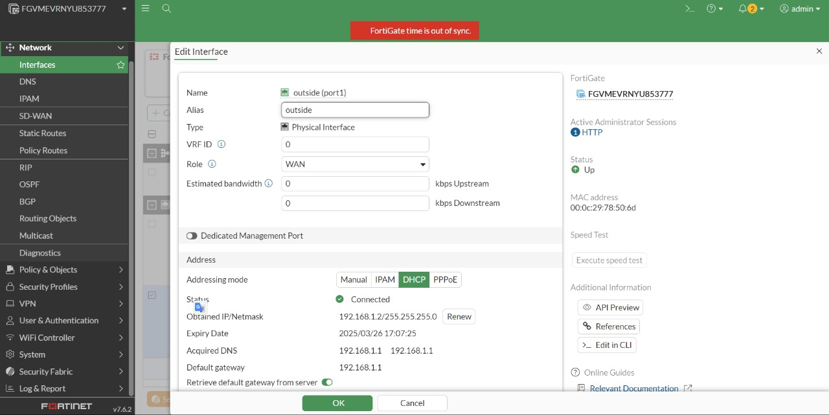

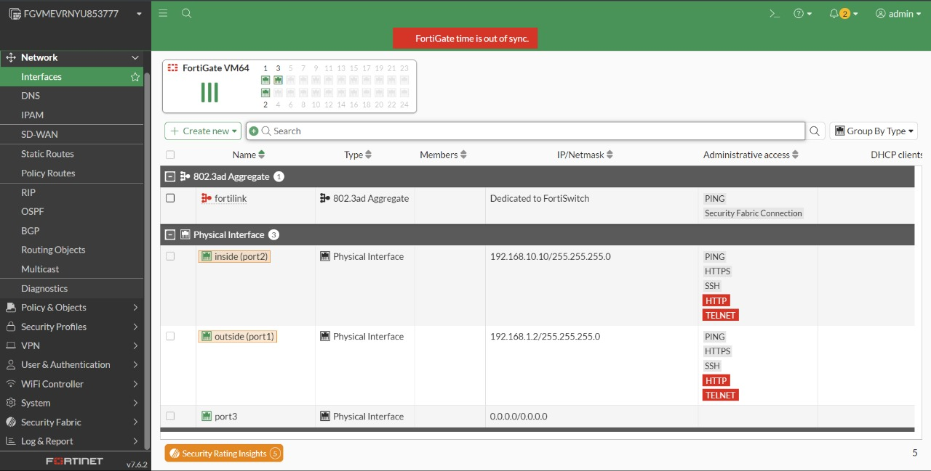

**3-Create a group policy to allow Lan network connect to outside**

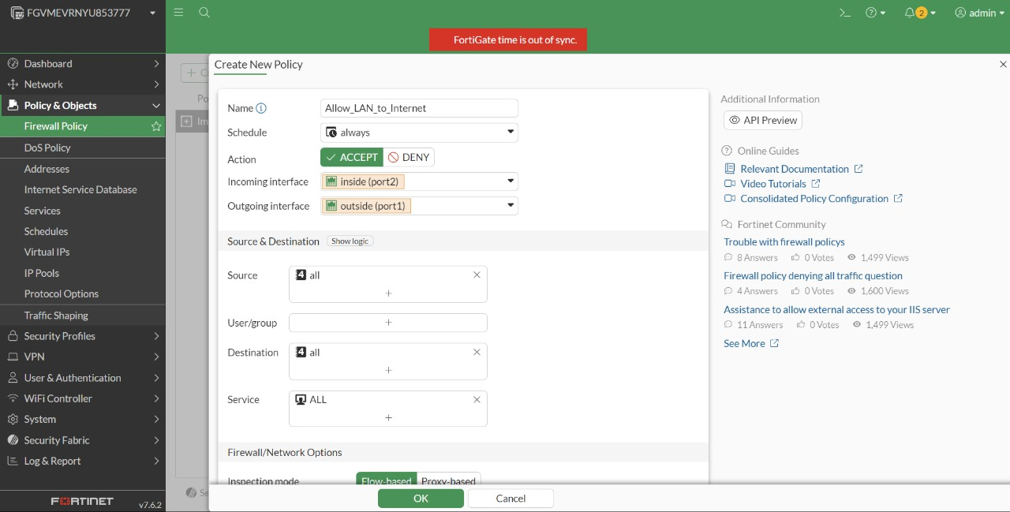

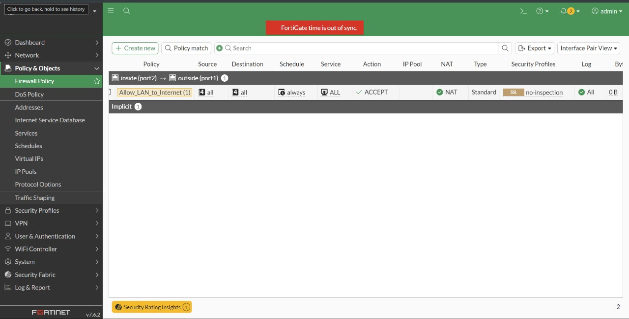

**4-Check connectivity**

